This series of power supplies can generate output that ranges from 3kV to 6kV, 3kW to 6kWand are housed in compact 19” racks to give a highly regulated output. These unit are typically used for glow discharge application.
REGULATED HIGH VOLTAGE POWER SUPPLY
-6kV, 1A
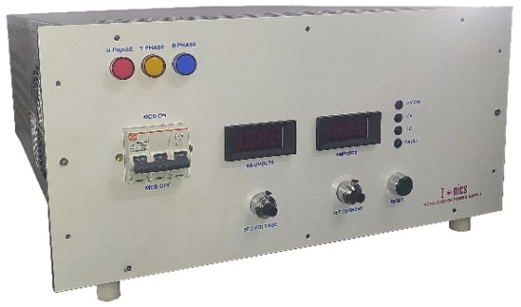
Features:
- Precision Regulated
- Low Ripple
- High Stability
- 19” Rack Mountable
- OEM Customization Available

Technical Specifications
PARAMETER | SPECIFICATION
Input Voltage | 415V±10% AC, 50Hz, three phase
Output Voltage | 0 to 6kV DC
Output Current | 0 to 1A
Polarity | Negative
Voltage Regulation | Line regulation: ≤0.05% of full voltage and +500mv over the specified input range.  Load regulation: ≤0.1% of full voltage and +500mv for no load to full load change.
Current Regulation | Line regulation: ≤ 0.1% of full current over the specified input range.  Load regulation: ≤0.2% of full current and +/- 100uA for any voltage change.
Stability | ≤ 0.05%/hour after 1 hour warm up
Temperature Coefficient | < 0.05%/ºC
Regulation Mode | Constant voltage – Constant current
Voltage & Current Control | Local: By 10-turn potentiometers with lockable counting dials on the front panel over entire range from zero to maximum rating  Remote: Control through computer interface*
Protections | Against over current, over voltage, over temperature, short-circuit and arc
Remote Controls & Signals through D-Connector (External RS232 Microcontroller Module) * | 10V DC reference  10V DC HV enable signal  0 to 10V DC signal for voltage & current control  0 to 10V DC signal for voltage & current monitoring
Protections | Against over current, over voltage, over temperature, short-circuit and arc
Cooling | Forced air
Front Panel | MCB for mains power ON/OFF with indication  3½ digit voltage and current meters  10-turn potentiometers for voltage and current control  LED indication for faulty trip  Push button to reset trip condition  Constant voltage – constant current mode indication
Back Panel | Terminal block for mains input  Fuse holders with fuse  Terminals for output  Stud for grounding the unit
Topology | High frequency resonant / PWM-controlled switch mode
Switching Device | IGBT
Cabinet | 19” rack, powder coated

*Optional. RS232 interface available at an extra cost.

Remote Interface Connector Configuration
Pins | 14 Pin Pluggable Connector | 25 Pin D Connector
1 | Earth | Earth
2 | Common | Common
3 | Interlock | HV Enable
4 | HV Enable | Voltage Control Remote
5 | 10 V DC Reference | Current Control Remote
6 | Common | Over Voltage Control Remote*
7 | Voltage Control Remote | Over Current Control Remote*
8 | Voltage Control Local | Common
9 | Common | Voltage Monitor
10 | Current Control Remote | Current Monitor
11 | Current Control Local | Reserved Monitor*
12 | Common | Reserved Monitor*
13 | Voltage Monitor | Common
14 | Current Monitor | Mode Status
15 |  | Interlock Status
16 |  | HV ON Status
17 |  | Common
18 |  | PS Fault Status*
19 |  | Over Voltage Status*
20 |  | Over Current Status*
21 |  | Over Temperature Status*
22 |  | Open Circuit Status*
23 |  | Phase Failure Status*
24 |  | Reserved Status*
25 |  | Common

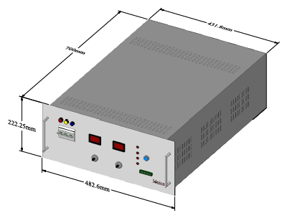
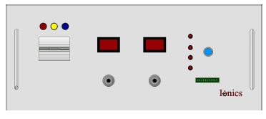
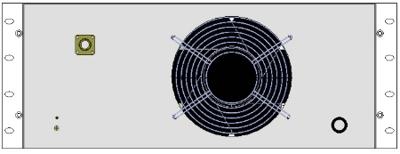

For any queries or customization requests contact us at info@ionics.co.in
For product line information visit us at www.ionics.co.in

